Problem Statement: We will implement a CI pipeline using GitHub Actions for Spring Boot project.
Advantage: Whenever code is pushed to the main branch, GitHub automatically checks out the code, configures Java 17, runs the Maven build, and verifies that the application compiles successfully. This helps identify build issues early and ensures that only valid code moves further in the delivery pipeline.
No one manually builds the application after every code change.
Tools commonly used:
- GitHub Actions
- Jenkins
- GitLab CI/CD
- Azure DevOps

Step 1 : Create these folders inside the project root:
ITP_PP1_Springboot
│
├── .github
│ └── workflows
│ └── build.yml

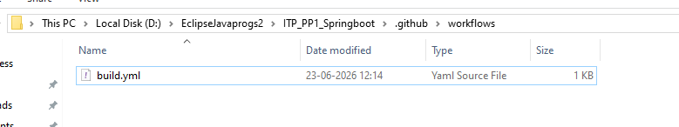

NOTE : .github Folder might be “hidden” not be visible in eclipse
So try to view folder in file explorer
View
→ Hidden items (checkbox tick)

Also make sure build file extention is .yml & not build.yml.txt

File Explorer
→ View
→ File name extensions (checkbox tick)
→ Rename the file to the correct extention(.yml)

Step 2 : In build.yml

name: Spring Boot Build

on:
workflow_dispatch:

push:
branches:
- master

jobs:
build:
runs-on: ubuntu-latest

steps:
- uses: actions/checkout@v4

- name: Setup Java 17
uses: actions/setup-java@v4
with:
distribution: temurin
java-version: 17

- name: Build Application
run: mvn clean install -DskipTests

push code to github

got to github.com -> repo-> Actions Tab
the workflow should be running

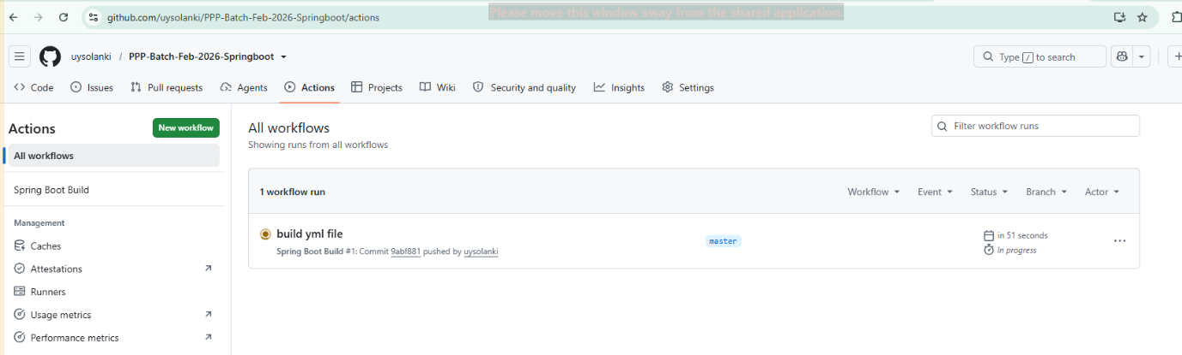

Write code
↓
Push to GitHub
↓
GitHub automatically builds project
↓
Reports success/failure
↓
Early detection of issues

This is the first step of CI (Continuous Integration). The next step is CD (Continuous Deployment), where after a successful build GitHub automatically deploys your Spring Boot application to a server.

Updated:
name: Spring Boot Build

on:
workflow_dispatch:

push:
branches:
- master

jobs:
build:
runs-on: ubuntu-latest

steps:
- uses: actions/checkout@v4

- name: Setup Java 17
uses: actions/setup-java@v5
with:
distribution: temurin
java-version: 17

- name: Build Application
run: mvn clean install -DskipTests

